Notes

Notes

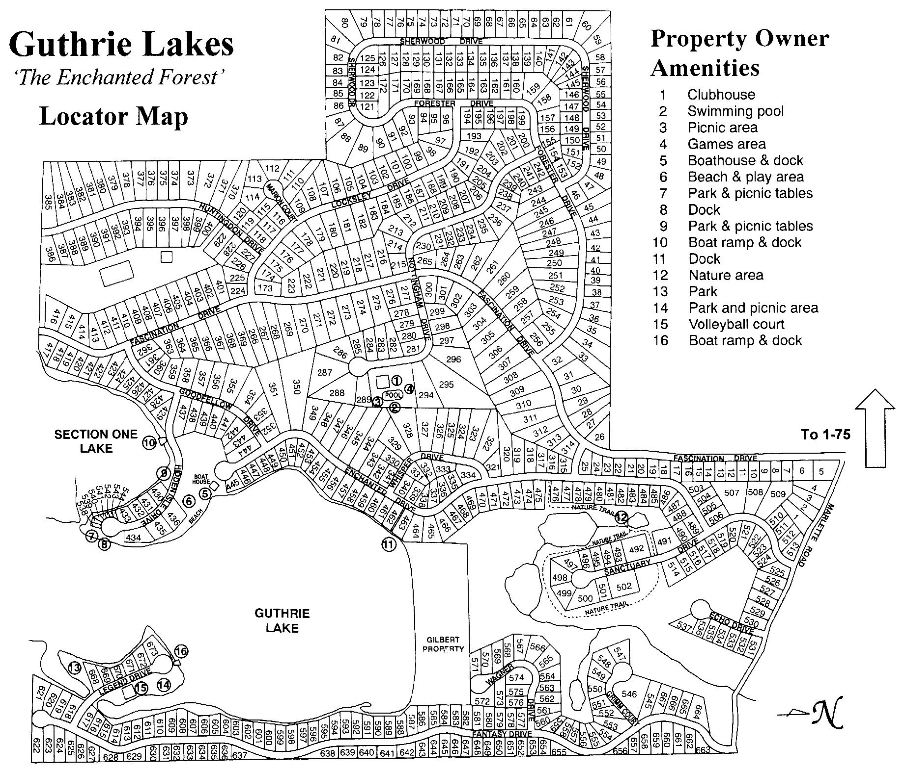

1. Clubhouse
2. Swimming Pool
3. Picnic Area
4. Games Area
5. Boathouse & Dock (White Birch Park)
6. Beach & Play Area (White Birch Park)
7. Park & Picnic Tables (Hidden Isle Park)
8. Dock (Hidden Isle Park)
9. Park & Picnic Tables (Wilson’s Park)
10. Boat Ramp & Dock (Gilberts Landing)
11. Dock (Dorthea’s Walkway)
12. Nature Area (Sanctuary West Nature Trail)
13. Park (Stephanie’s Peninsula)
14. Park & Picnic Area (Legend Park)
15. Volleyball Court (Legend Park)
16. Boat Ramp & Dock (Legend Park)