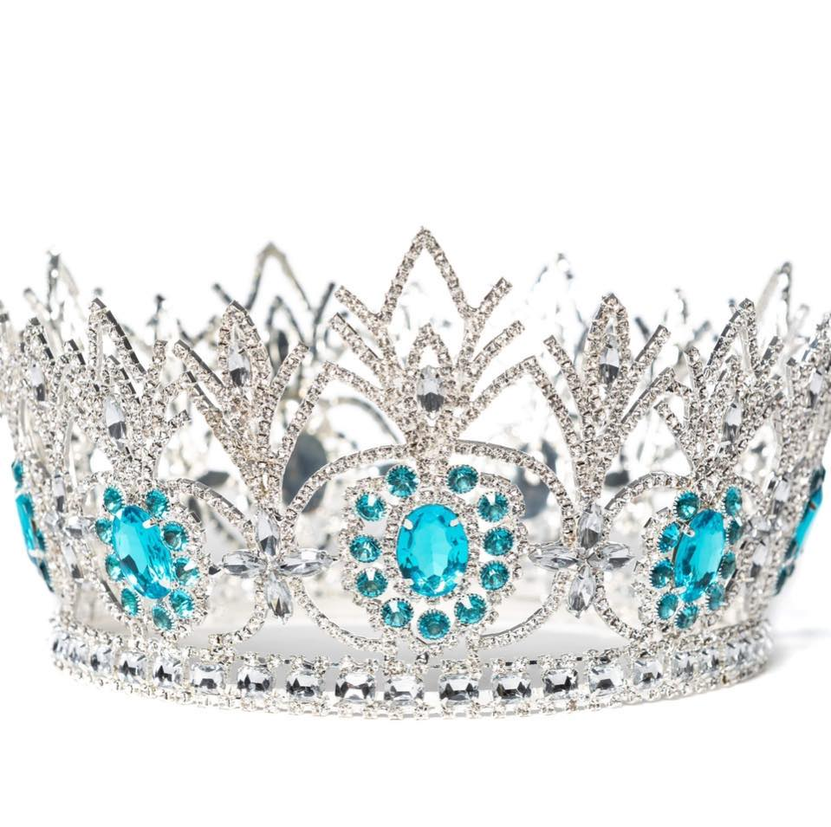

Finalist Fundraising Guide

Welcome to Pure!
At Pure, we understand that sometimes dreams and finances need a little help. We are providing some ideas and tips for you to use to help you with your pageant expenses. We will also give you some great budgeting tips to make your journey to the crown more fun!

FUNDRAISERS
The best fundraisers are those that have little to no up-front investments. Some examples could be a car wash, bake sale, or helping a friend or family member with chores like mowing the lawn, pet sitting, house sitting, tutoring children, or even babysitting.

Other fundraising ideas include something like a 50/50 Split the Pot Raffle, selling candy bars or other low investment items. There are also some ideas like a “Calendar Day” sale or even a “Spot on the Crown” sale in this packet. Information is enclosed for these ideas. You can volunteer to work as a waitress for a day at a local restaurant for tips.

GROUP FUNDRAISERS
While it’s not his/her job to do fundraisers for you, your director may offer a group fundraiser that everyone can work together on and split the profits. But remember, you must participate to receive your share. This is also a great way to get to know your sister queens better and have fun while doing it!

BUDGETING TIPS
PURE has one required fee to participate in our pageants, a Sponsorship fee, and at times, purchase an opening outfit. Beyond that, you are invited to participate in any of our Optional Programs, including the world’s largest International Super Star Competition. Additional costs would be things like your wardrobe, travel, and meals.

CREATE A PAYMENT PLAN
We find most people are less stressed by making multiple small payments instead of waiting to make one big payment. Our Tally Genie registration system allows you can make payments of any amount at any time. When you register for your National Pageant, you should pay a deposit of $100 or more your National Sponsorship fee. When you register for the International Pageant, you should pay deposit of $150 or more on your International Sponsorship fee. You have 90 days to pay your fee in full or by your deadline date, whichever comes first. This gives you time to put your fundraising plans into action.

We also work with a company called Squareup (https://squareup.com/us/en) to offer their program called “AFTERPAY” which allows you to pay your sponsorship fee and pageant purchases up to $2,000 with no credit check and gives you the option of dividing your balance into 4 payments, with 1 due at the time of transaction, and 6 weeks to pay off your account. There is no credit check, no fee to apply, and no interest on your account!! To use Afterpay for our system, go to
Pure International Pageants (square.site)

BUDGET GRID
There are many programs offered within PURE to help our finalists succeed. One of our favorites is our Budget Grid. A Budget Grid can be used to help you focus on your goals and dreams and to help you track your progress. Be sure to check out the Budget Grid in this packet.

FAMILY, FRIEND, AND BUSINESS SPONSORSHIPS
Your Finalist Handbook and this Fundraise Guide provides you with a sponsorship letter that you can mail or take with you to visit family, friends, and businesses you associate within your community. Many people are excited to partner with you on your journey to the crown. Simply mail or hand out the sponsorship letter and be prepared to answer any questions your sponsors may have.

DRESS THE PART
When soliciting sponsorships, holding fundraisers, selling program book ads, or even holding a social media event, dress the part! We always say, “dress to make your crown look good”. People want to see how serious you are about your journey, so looking your best while out and about is the best way to show them how serious you are about landing your dream job!

PRACTICE
Practice your sales pitch before going out to speak with people. Practice in front of a mirror and for family and friends. Even video yourself and then watch it to see what you can improve on. These steps will help to calm your nerves and get you focused before putting on your crown and sash and hitting the pavement.

VERBIAGE
So, what do you say to people when you are soliciting sponsorships, selling ads, or trying to get them to participate in your fundraisers?
Sometimes finding the right words to say is hard. Here are some ideas to help you.
- Create your opening statement. Example: “Hello, I’m Pat and I am competing for the title of Pure International Classy Ms. Great Lakes USA. Part of my journey to the crown is developing my public speaking and communication skills. There’s no better way to do that than to include my family, friends, and community in my journey to the crown. Do you have a moment?”
- Know what the pageant system is about. You should know what our mission statement, our national platform, and history of PURE is. But don’t limit your knowledge to just that. Learn about the owners and any other information you can to tell people why you love PURE. We are an international pageant that has representation from 20 countries and almost every state in the USA. Visit our website for more information.

INFORM YOUR DIRECTOR
Always let your director know about the fundraisers you are doing. There may be times when someone may want to know more about where their money is going, and your director can always share more information with your sponsors.

MONEY WISE
Don’t forget all money raised must be applied to pay your pageant fees first and then to additional expenses. Please visit our website on more information about fundraising and payment guidelines or contact your director for more information.

PURE INTERNATIONAL FINALIST BUDGET GRID
EXPENSES | BUDGET | COST | DUE DATE | PAID | BALANCE | NOTES
Sponsorship Fee
(required)

HELP ME FILL MY CROWN WITH CASH!

Simply choose a circle with a cash amount of your choice. Your sponsorship will be that amount. Once my crown is full, I will reach my goal of $500

Row 1, small circles are $20 each
Row 2, medium circles are $30 each
Row 3, the 2 circles to the left and the 2 circles to the right of the center circle on the crown are $40 each
The TOP circle on the crown is $50

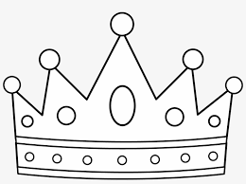

BE PURE CALENDAR SPONSORS
Will you help me on my journey to the crown?

How it works. Choose a day of the month to sponsor me. Whatever date you choose is how much you will sponsor. Write your name on the date and you can pay in cash, PayPal, or check. Payment is due at time of sponsorship. (Hint: You can sponsor as many days as you like or make a donation of any amount below.) THANK YOU FOR YOUR SPONSORSHIP!

Example: Choose Day 15, then your sponsorship is $15

DAY 1 | DAY 2 | DAY 3 | DAY 4 | DAY 5 | DAY 6 | DAY 7
DAY 8 | DAY 9 | DAY 10 | DAY 11 | DAY 12 | DAY 13 | DAY 14
DAY 15 | DAY 16 | DAY 17 | DAY 18 | DAY 19 | DAY 20 | DAY 21
DAY 22 | DAY 23 | DAY 24 | DAY 25 | DAY 26 | DAY 27 | DAY 28
DAY 29 | DAY 30 | DAY 31 | PERSONALIZED  SPONSORSHIP | PERSONALIZED SPONSORSHIP | PERSONALIZED SPONSORSHIP | PERSONALIZED SPONSORSHIP

