 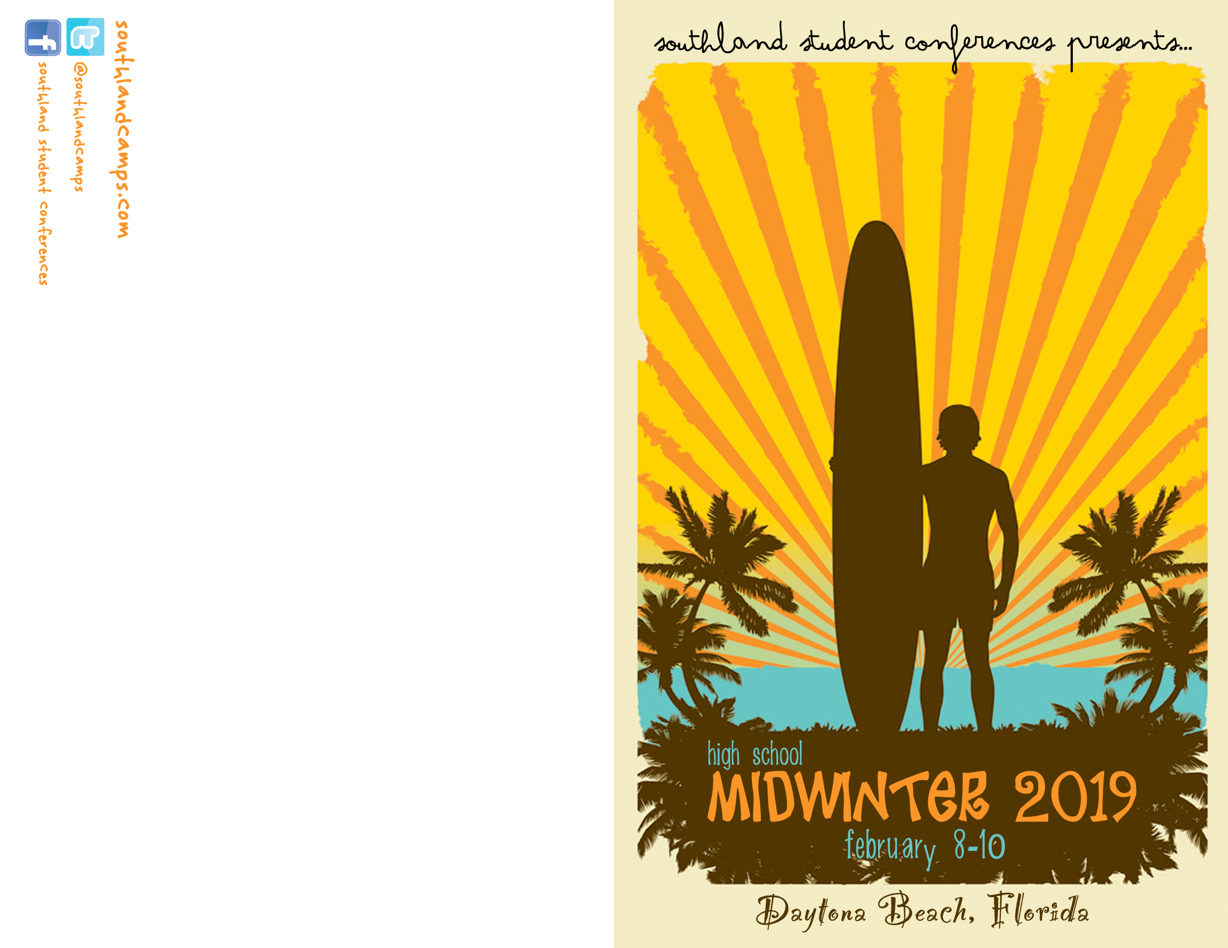



**POSTAGE  
REQUIRED**

*REDEEMER PCA RIVERVIEW  
12404 Boyette Road  
Brandon, FL, 33569*

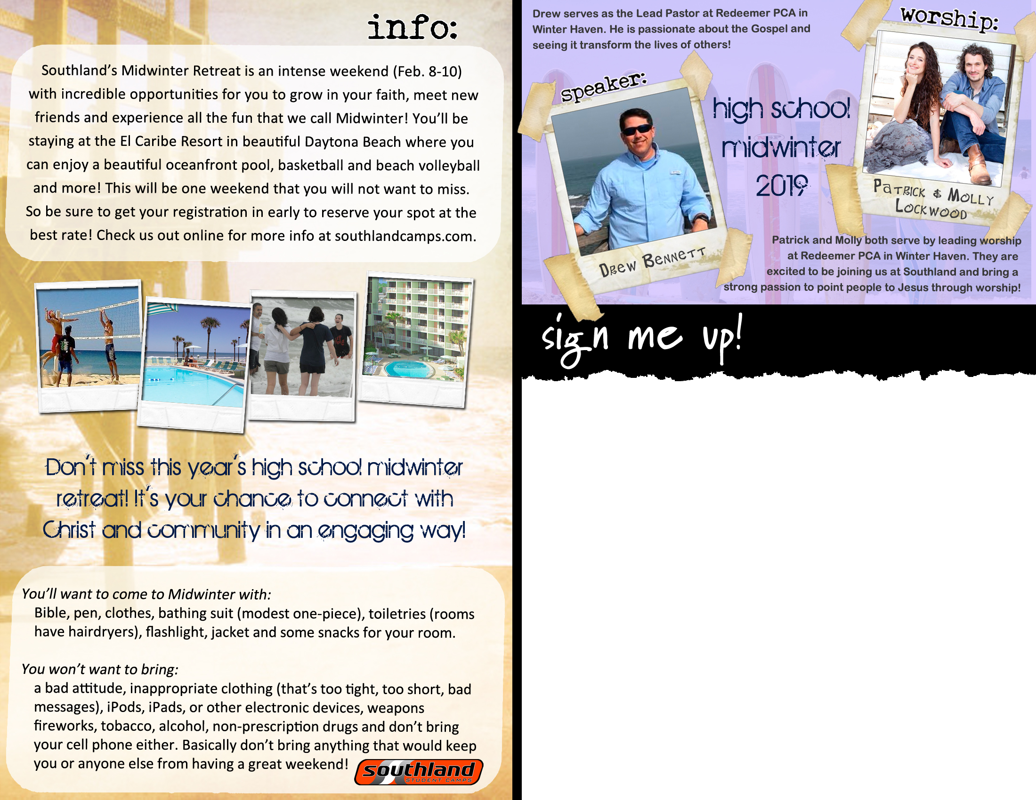

Registration Cost of $125 per student covers snacks, t-shirt, meals, resources, and activities for all 4 days. Scholarships available on a first-come, first-served basis. To sign-up today, simply fill out the registration portion below and submit to Pastor Josh in-person or via email at **josh@redeemerriverview.org**.



Balance due by July 27th along with health form & waiver.



Redeemer Student Summit is a 4-day intensive (July 27-30) with incredible opportunities for students to grow in their faith, meet new friends, and experience all the fun that Hillsborough County can offer! We will be gathering locally, socially distant at Redeemer Church for fellowship, competition, and gospel teaching through Matthew 5 and Jesus’ Sermon on the Mount. We will have afternoon activities daily including paintball, pool party, Lake Day, and lock-out. See attached daily itinerary for more details or visit www.redeemerriverview.org/student_ministry



Name: ________________________________________ [ ] M [ ] F

Address: _____________________________________________

City: ________________________________ Zip: _____________

Email: ________________________________________________

Phone: ____________________ (h) _____________________ (c)

Grade: ______ [ ] counselor T-shirt Size: S | M | L | XL | XXL

*Please complete this registration and turn it in to the Student Ministry Office.*

**STUDENT SUMMIT COST**

REGULAR (by 7/26/20) $125 [ ]

*Please make checks payable to Redeemer Church. A completed, notarized Medical Release Form needs to be on file in order to participate in this event.*

*\*\* THIS TEXT BOX CAN BE EDITED \*\**