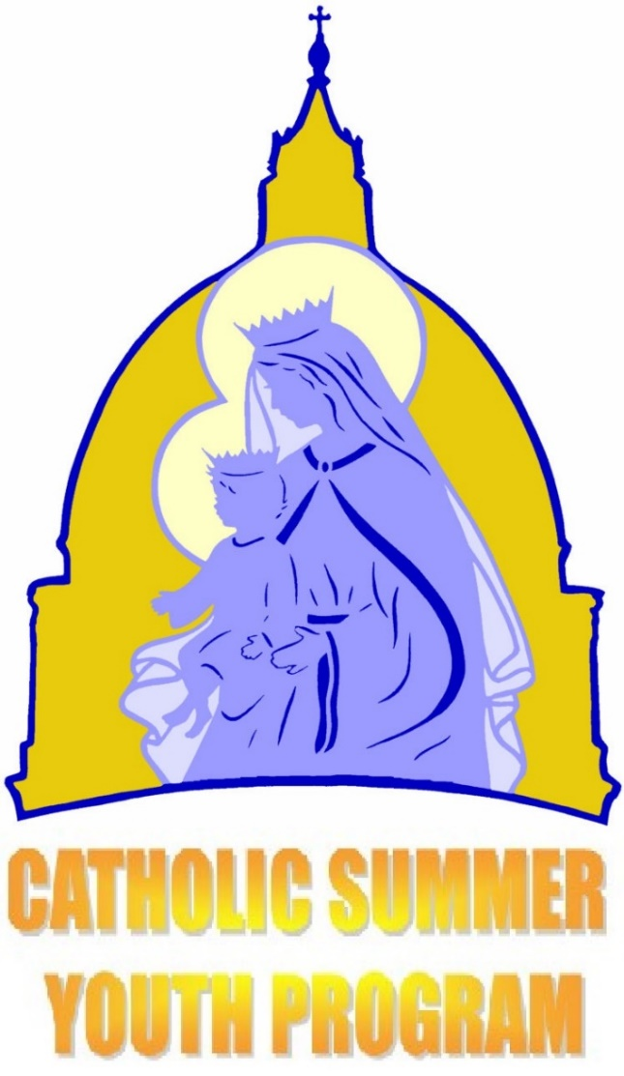
Totus Tuus
St. Mary Parish is hosting a Totus Tuus team from the Dodge City Diocese.
June 12th through June 17th
Grades 1-6
(the grade student will be in the fall)
Monday – Friday from 9am to 3pm

Grades 7–12
(the grade student will be in the fall)
Sunday – Thursday from 7pm to 9:15pm

Ego sum Maria
Totus Tuus is a Catholic youth program dedicated to sharing the Gospel and promoting the Catholic faith through catechesis, evangelization, Christian witness, and Eucharistic worship.

Totus Tuus

Ego sum Maria

Totus Tuus is a Catholic youth program dedicated to sharing the Gospel and promoting the Catholic faith through catechesis, evangelization, Christian witness, and Eucharistic worship.

Totus Tuus es un programa de verano de la juventud Católica dedicada a compartir y enseñar la Fe Católica, mientras que incorporamos la devoción Mariana, la adoración del Santísimo, las vocaciones, la oración, la catequesis, y ¡la diversión!
Cuota: $20 por niño o $35 para familias de 3 o más niños.
Pase a la oficina para las inscripciones o en línea en:
stmarygc.com
~~~~~~~~~~~~~~~~~~~~~~~~~~~~~~~
Cost: $20 per child or $35 per family of 3 or more children.
Register in the parish
office or on line at our
website: stmarygc.com

