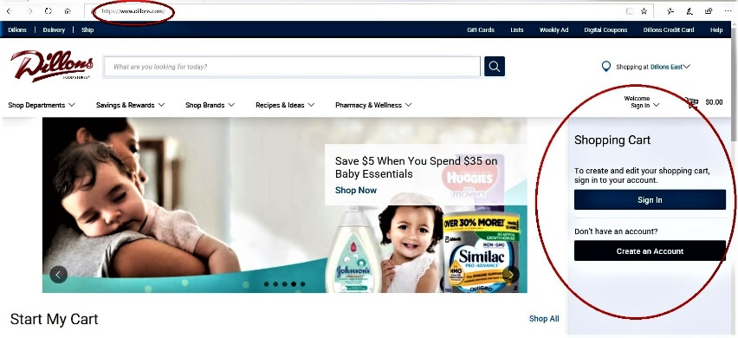
Dillons (Kroger)
Community Rewards
to benefit
St. Mary Catholic School

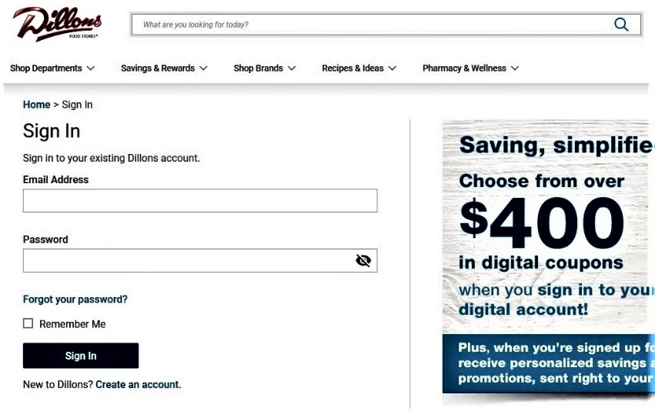
The easiest way to get to the Dillons

website (on your phone or computer) is
to go to https://www.dillons.com

on the right hand side there is a place to
sign in or to create an account. This can
also be done under “sign in”

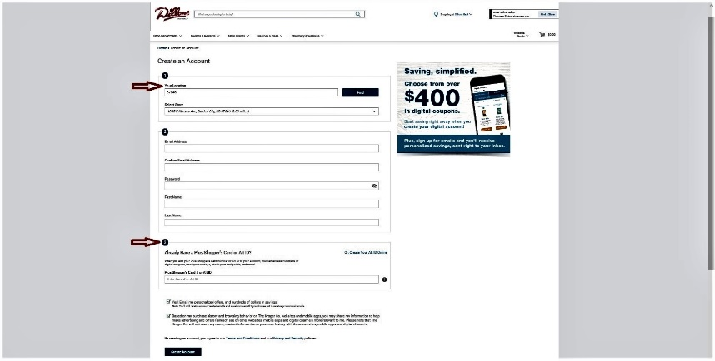
When creating an account, you will be asked for the location of the store (Dillons East or West), your personal address information and finally your Plus Shopper’s Card number. At the bottom of the screen is the final button to push to create your account.
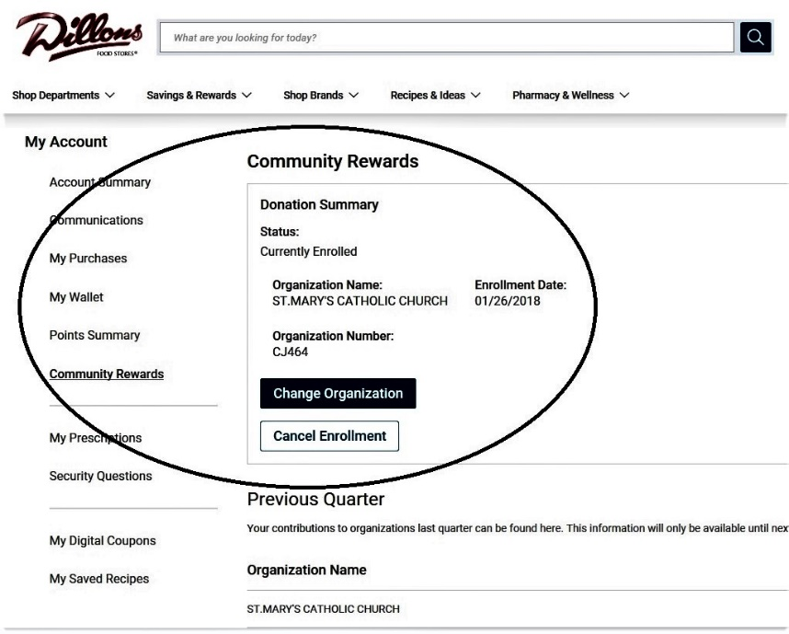
Once your account is created, you must go to “my account” and you will be able to choose the group that will benefit from your “Community Rewards”. You do this by using the organization number or name. The organization number for St. Mary Catholic School is
CJ464
ST. MARY CATHOLIC CHURCH
All money earned through this program will benefit St. Mary Catholic School.

