57-60 F-Series installation
Tools required: ½” wrenches, 9/16” wrenches, 5/16” drill bit, ¾” wrenches

Remove hood.
Remove hood hinges from fender and cowl.
Save these bolts to reuse or you can use the new ones provided.
Install the rear roller brackets, with the u-shaped end towards the firewall, in place of the hood hinges at the cowl using 3/8”x1 ¼” bolts with a washer on the bolt and under the nylock nut. Use 5/16”x1 ¼” bolts with washers and nylock nuts to bolt to the fender.
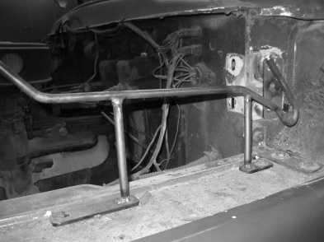
Install front pivot bracket. The front of this bracket should be installed 7/8” back from the front of the core support. The outside of this pivot bracket should line up with inside edge of the fender. Drill a 3/8” hole in the inner fender at the center of the adjusting slots. 3/8”x1 ¼” bolts are used for this with a washer on the bolt and a washer under the inner fender with a nylock nut. The support brace will mount to the pivot bracket using the 3/8” carriage bolts and nylock nuts with a flat washer under the nut. Drill a 3/8” hole in the fender centered on the slots. 3/8”x1 ¼” bolts with flat washers on the bolt and under the fender with nylock nuts.
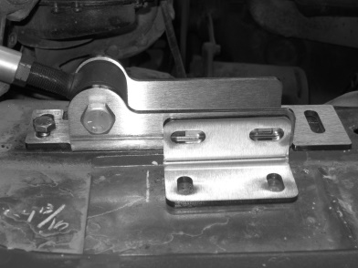 Leave these loose at this time. Repeat for the opposite side.
Install rod ends into the aluminum tubes. Adjust the rod ends to approximately 17 3/8” to 17 ½”” from center to center of rod ends. Tighten jam nuts. I recommend using anti-seize on these.
Install the tube assembly into the hinge bracket with the 2 ½”x1/2” bolt and nylock nut. Leave these bolts loose at this time. The rod ends should be approximately 60 ¼” outside to outside.
The driver’s side tube must have the knurled end towards the pivot bracket at the core support.
The passenger side tube must have the knurled end towards the hood bracket.
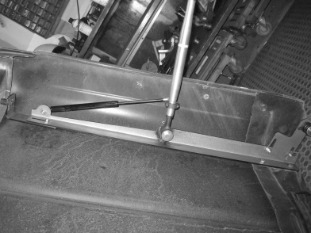
This is important because the gas shocks will push on the jam nuts. If they are installed improperly, they will push on the tubes, loosen the jam nuts and pop the gas shocks out of the mounting balls.
Install shaft collar on the aluminum tube approximately 1” down from the top of the tube to the top of the shaft collar with the shock mount facing towards the outside of the truck.
1
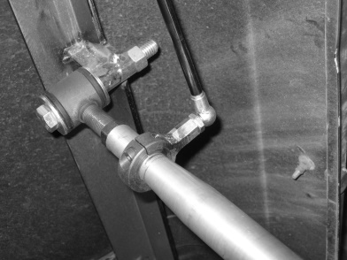
Parallel the tubes to approximately 60 ¼” apart outside to outside of rod end. Snug the bolts on the pivot bracket.
The angled aluminum spacer will be installed in front of the pivot bracket. Bring the aluminum tube forward to center the angled spacer. This should be installed 1 ¾” to the center of the angled spacer in front of the face of the core support. Drill a 3/8” hole. Put the nylon washer under the angled spacer with the angle facing towards the rear of the truck and install the rubber bump stop on top
Install the long hood brackets to the original hinge mounts on the hood using the factory bolts or the supplied 3/8” x 1” bolts and flat washers. Mount this bracket with it pushed as far towards the front of the hood as possible.
Install the large L-bracket to the front of the hood bracket with 2 - 5/16”x1” bolt w/washers and nylock nuts. Leave this loose at this time. Install the 1” spacer between the large L-bracket and the inner structure of the hood. Mark and drill a 5/16” hole in the inner structure. Use the 5/16”x2” bolts with flat washers and nylock nut.
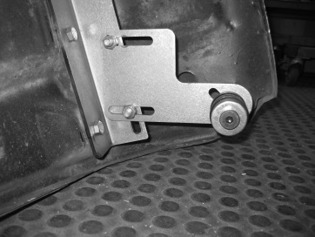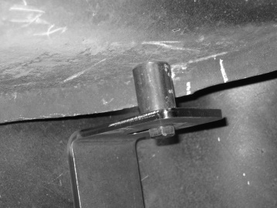
Install flat L-shape roller mounts onto the outside of the hood bracket with 3/8” x 1”bolts, flat washers and nylock nuts at the back of the hood bracket. Install a flat washer on the bolt and under the nut. This can be mounted on the inside of the bracket if needed to line up with roller bracket mounted to the cowl.

Install the rollers on the flat bracket with the roller facing towards the inside of the truck. Install the 3/8” flat washer on the outside of the bracket with the thin nylock nut. Center the roller in the slotted hole. This can be adjusted later for final fitting. Roller can be turned around to move the roller in or out due to the shim made into the roller.
Remove the aluminum tubes and rod ends from the hinge brackets. Mount them to the hood bracket in the proper direction with the 3 ½” x ½” bolts, using a flat washer on each side of the rod end. See attached picture. Install the ½” nylock nut on the outside of the hood bracket. A flat washer is not needed under the nut. Tighten these nuts and bolts.
Install the gas shocks from the shaft collar to the front of the hood bracket with the large end of the shock mounted to the hood bracket.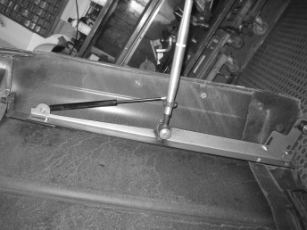
2

With an assistant, install the hood assembly back into the pivot bracket, re-install the bolts, nuts and tighten.
Tighten all nuts and bolts at this time.

The 4 rubber plugs go into the holes in the firewall where the factory hinge was removed. I recommend a little bit of adhesive around these to make sure that they keep wind out.

Final adjustments:
If the hood is too close to the cowl, shorten the aluminum tubes. The rod ends on the tubes are left and right hand threads. Use a clamp behind the roller to keep the hood from closing when you remove the shock. Remove the shocks, loosen the jam nuts and turn the tubes to shorten. One revolution will move the hood approximately 1/8”. If the hood is too far away from the cowl, turn the tube the opposite direction. Tighten the jam nuts, install the shocks and check the hood for fit.
If the hood is too high in the back, adjust the flat roller bracket, forward or backwards until it sits correctly. The roller can also be adjusted on an angle to allow the hood to sit properly.
The back of the hood bracket can be moved from side to side to help align the side of the hood with the cowl.
This all takes time, but you can get a perfect alignment.

If you have questions,
My cell phone number is 602-376-7467 7 AM until 8 PM (MST)
Kevin Stone
Copperstate Components LLC
18631 N. 19th Ave.
Suite 158-206
Phoenix, AZ. 85027
kevin@copperstatecomponents.com
www.copperstatecomponents.com
www.forwardtilthoodkits.com

3

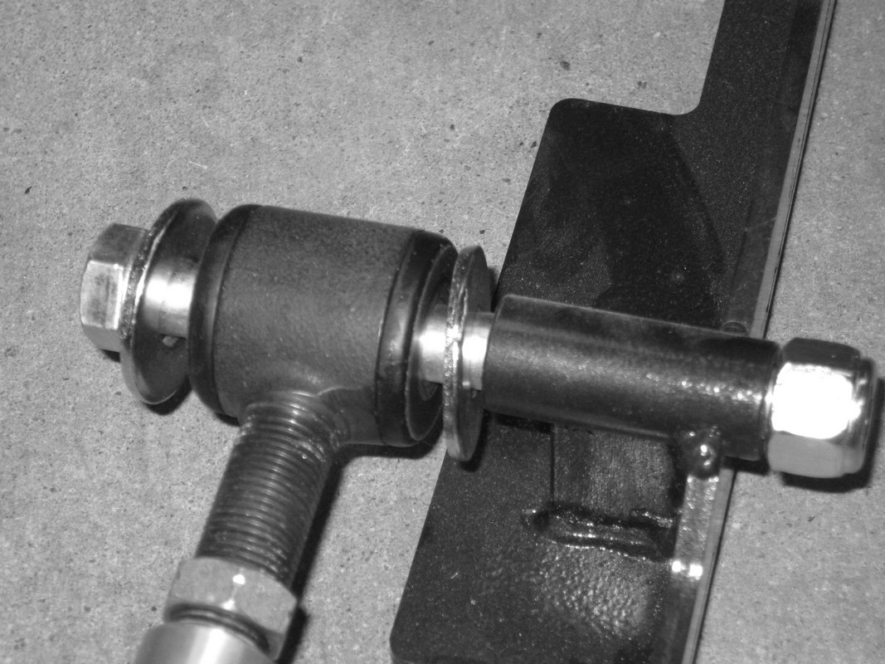

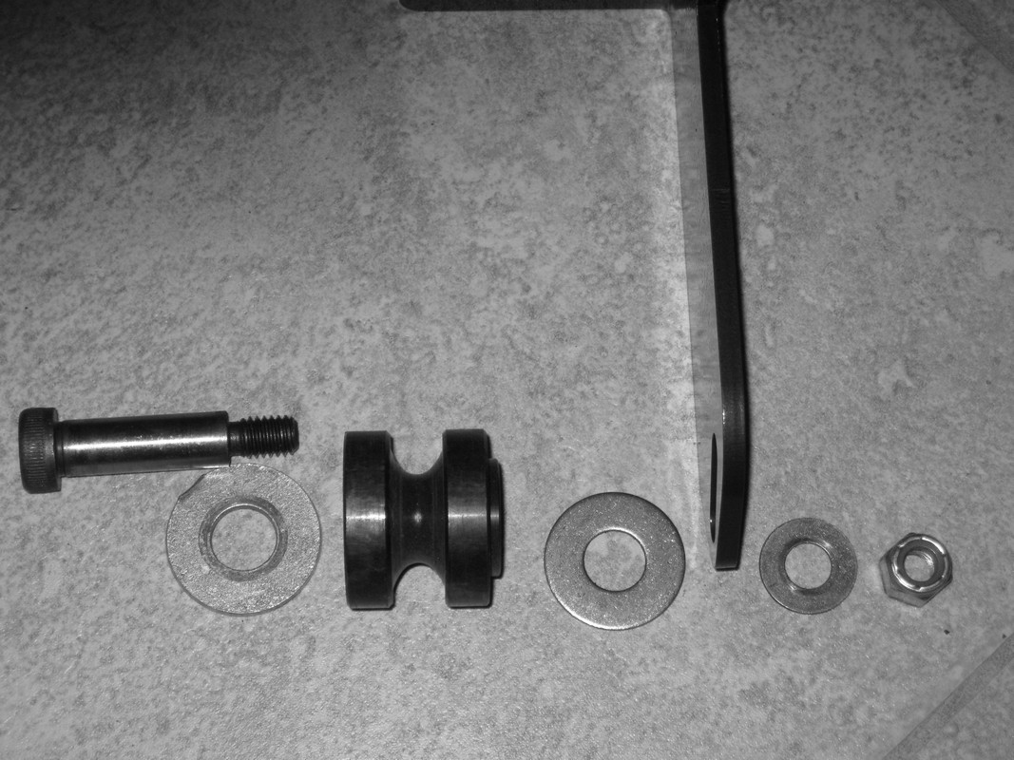

4

