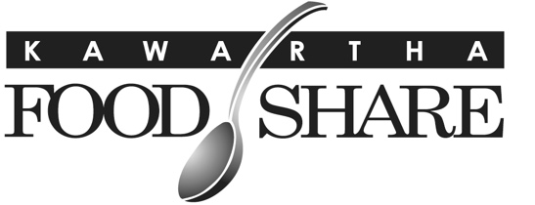
665 Neal Drive, Unit #1
Peterborough, ON
K9J 6X7
705-745-5377 ex. 200 ▪ www.kawarthafoodshare.com

Privacy Policy- Food Bank Clients
Collection of Personal Information at Food Program Intake

This policy applies to information we collect, use, or disclose about you when you visit a member agency within the Kawartha Food Share network, if you choose to share your personal information with us. By accessing food programs in the Kawartha Food Share
network, you indicate that you understand, accept, and consent to the practices described in this policy.

Client Information we Collect

When you visit a KFS member agency, they may collect and use certain types of information from and about you, including:
• Personal Information: Information that can reasonably be used to directly or indirectly identify you, such as your name, birthdate, gender, racial identity, disability status, dietary considerations, residential address, primary source of income, residency and immigration information, housing type, educational information, and other identifiers.
• Non-Personal Information: Information that does not directly or indirectly reveal your identity, such as demographic information or statistical or aggregated information.

Link2Feed System

A staff member or volunteer at the agency you are visiting within the Kawartha Food Share network will enter or update your information in “Link2Feed,” a third-party software for storing and accessing the personal information of food program visitors. Link2Feed is used by every Kawartha Food Share Member Agency as mandated per our provincial association, Feed Ontario. Agencies do intake with clients and have access to the personal information provided in the Link2Feed database for the purposes of delivering their programs and service offerings and creating detailed reporting and tracking statistics. Agency staff and volunteers are required to protect personal information and keep all client information confidential.

Consent to Collection, Use and Disclosure

By providing your personal information to staff and volunteers at KFS member agencies, you are providing your consent for us and our network to collect, use and disclose your personal information in accordance with this Privacy Policy and applicable laws. No compensation is offered for sharing your information. You may withdraw your consent at any time, subject to applicable laws.
You may also withhold your consent to providing personal information and you may consent to provide some but not all of any requested personal information - you do not have to provide us a reason for withholding consent. Note that if consent is withheld, it will not affect whether you are able to receive food.

Use of Information

To the extent applicable and permitted by law, we may use your personal information in the following ways:
- To record your food program visits to help us understand your situation and food needs.
- Maintain accurate statistics around food insecurity in Peterborough and County
- Measuring change in community food insecurity and food program use
- Deciding which food and how much food to purchase and distribute to member agencies based on volume of clients served
- Reporting back to funders that support our operations;
- Attracting donors;
- Advocating for government policy changes; and

Food Banks Canada

Our requests for information are generally set by the national food bank association: Food Banks Canada. If you have questions or concerns about the information being requested, you may contact the Food Banks Canada Customer Experience Hotline at 1-877-280-0329 or complaints@foodbankscanada.ca.

Breaches of Security Safeguards

If there are breaches of our security safeguards involving your personal information that pose a real risk of significant harm to you, we are committed to notifying the Office of the Privacy Commissioner of Canada
(OPC) and individuals affected in accordance with requirements under applicable law.

Data Retention

Except as otherwise permitted or required by applicable law or regulation, we will only retain your personal information for as long as necessary to fulfill the purposes we collected it for, including for the purposes of satisfying any legal, accounting, or reporting requirements. Following seven years of inactivity, personal data in Link2Feed is automatically anonymized. We reserve the right to use such anonymous and de-identified data as well as non-personal information without further notice to you or your consent.

