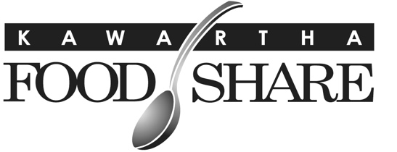
665 Neal Drive, Unit #1
Peterborough, ON
K9J 6X7
705-745-5377 ex. 200 ▪ www.kawarthafoodshare.com

The Ethical Food Banking Code

Food Banks Canada, its Members (provincial associations), Affiliate Member food banks and associated agencies believe that everyone in Canada has the right to physical and economic access, at all times, to sufficient, safe and nutritious food which meets their dietary needs and food preferences.

As an Affiliate Member of Food Banks Canada, KFS will:

- Provide food and other assistance to those needing help regardless of race, national or ethnic origin, citizenship, colour, religion, sex, sexual orientation, income source, age or mental or physical ability.
- Treat all those who access services with the utmost dignity and respect.
- Implement best practices in the proper and safe storage and handling of food.
- Respect the privacy of those served, and will maintain the confidentiality of personal information.
- Not sell donated food.
- Acquire and share food in a spirit of cooperation with other food banks and food programs.
- Strive to make the public aware of the existence of hunger, and of the factors that contribute to it.
- Recognize that food banks are not a viable long-term response to hunger, and devote part of their activities to reducing the need for food assistance.
- Represent accurately, honestly and completely their respective mission and activities to the larger community.

