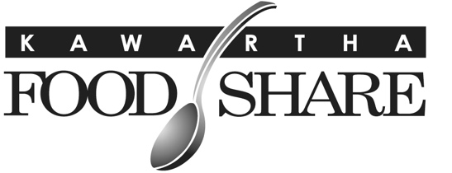
665 Neal Drive, Unit #1
Peterborough, ON
K9J 6X7
705-745-5377 ex. 200 ▪ www.kawarthafoodshare.com

Access to Services

Policy Statement
KFS is committed to providing all core food-support services to participating agencies and their clients at no financial cost and without being implicitly/explicitly tied to other conditions (e.g., volunteer participation, donation requirements, engagement in faith-based activities, etc.).

Procedure
The Ethical Food Banking Code which includes this provision is posted publicly.

Accessibility for People with Disabilities

Kawartha Food Share is committed to identifying, removing, and preventing barriers to accessibility and ensuring compliance with all applicable accessibility, employment, and health and safety legislation, including the Accessibility for Ontarians with Disabilities Act (AODA) and related standards. The organization will maintain and publicly share accessibility policies and procedures that comply with legislative requirements and demonstrate accountability, transparency, and continuous improvement. This policy applies to all KFS employees, Board members, volunteers, member agencies, and any individuals interacting with the organization.

Compliance with Legislation
This policy is developed and maintained in accordance with:
- Accessibility for Ontarians with Disabilities Act (AODA)
- Ontario Human Rights Code
- Applicable employment standards legislation
- Occupational Health and Safety requirements

Procedures and Oversight
- Policy Development and Review
  - KFS will maintain written accessibility policies and procedures that reflect current legislative requirements and best practices.
  - Policies will be reviewed at least annually by the General Manager, with input from staff and the Board of Directors as needed.
  - Updates will be made to ensure ongoing compliance with employment standards, customer service standards, and workplace health and safety requirements.
- Oversight and Accountability
  - The General Manager is responsible for overseeing accessibility compliance and implementation.
  - The Board of Directors will receive updates, as required, to ensure governance oversight.
  - The General Manager will ensure that accessibility considerations are integrated into operational planning, hiring practices, volunteer engagement, and service delivery.
- Accessibility Practices
Kawartha Food Share will:
  - Provide accessible customer service and accommodate individual needs to the best of its ability
  - Ensure recruitment, hiring, and employment practices are inclusive and non-discriminatory
  - Maintain a safe and accessible workplace in alignment with occupational health and safety requirements
  - Provide accommodations for employees, volunteers, and clients upon request
  - Communicate in accessible formats where possible
  - Promote dignity, independence, integration, and equal opportunity
- Training and Awareness
  - All employees and applicable volunteers will receive training on accessibility, including requirements under AODA and the Ontario Human Rights Code.
  - Training records will be maintained and updated as required.
- Feedback and Continuous Improvement
  - KFS will provide opportunities for feedback regarding accessibility barriers.
  - Feedback may be submitted verbally, in writing, or electronically.
  - The organization will respond to feedback and take reasonable steps to address identified barriers.

